System Architecture


- Introduction
- What is a System Architecture Diagram?
- Benefits of Using System Architecture
- System Architecture Diagram Examples
  - 1. System Test Architecture Diagram
  - 2. Content Assignment System Architecture Diagram
  - 3. E-Learning System Business Architecture Diagram
- Conclusion

Introduction
The architecture of a system reflects how the system is used and how it interacts with other systems and the outside world. It describes the interconnection of all the system’s components and the data link between them. The architecture of a system reflects the way it is thought about in terms of its structure, functions, and relationships.
In architecture, the term “system” usually refers to the architecture of the software itself, rather than the physical structure of the buildings or machinery. The architecture of a system reflects the way it is used and therefore changes as the system is used.
For example, an airport may be designed using an architecture where the control tower and departures lounge are close together in the same building, while the control tower is further away in the same airport.
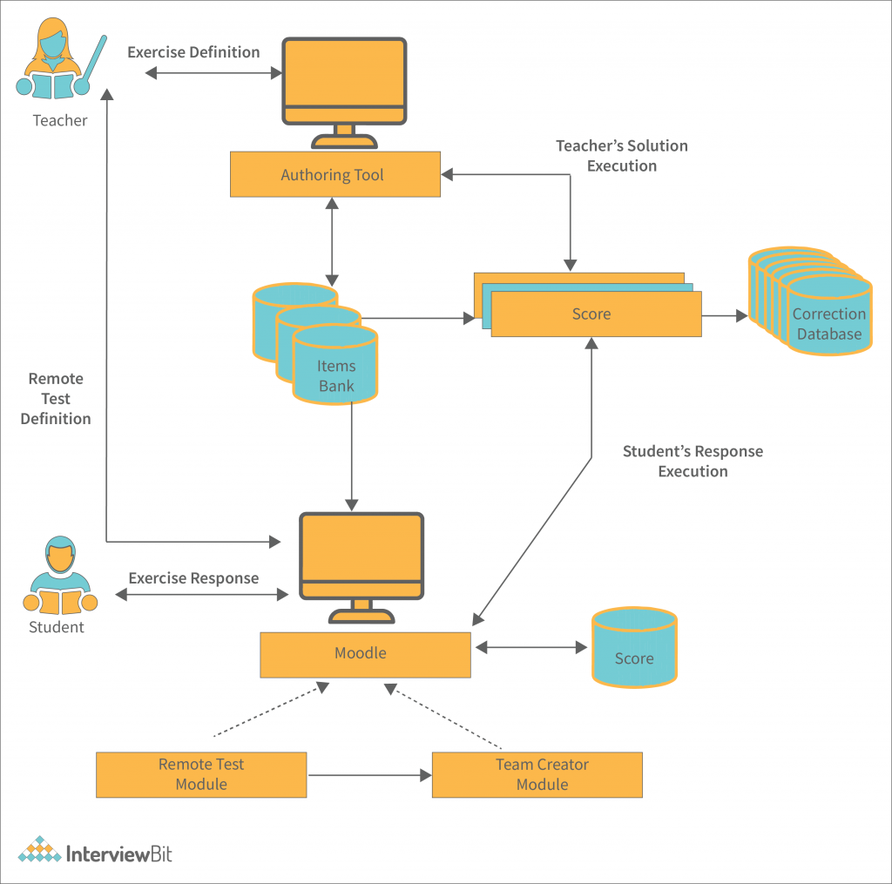
Therefore, the system is always described in terms of its parts and their operations. In the same way, data is always described in terms of the elements which compose it and the operations which make it useful to an end user. Now that we know the system and its parts, let’s dig into the data.

What is a System Architecture Diagram?
The system architecture diagram is an abstract depiction of the system’s component architecture. It provides a succinct description of the system’s component architecture in order to assist in component-component relationships and system functioning.
The system architecture diagram is a visual representation of the system architecture. It shows the connections between the various components of the system and indicates what functions each component performs. The general system representation shows the major functions of the system and the relationships between the various system components.
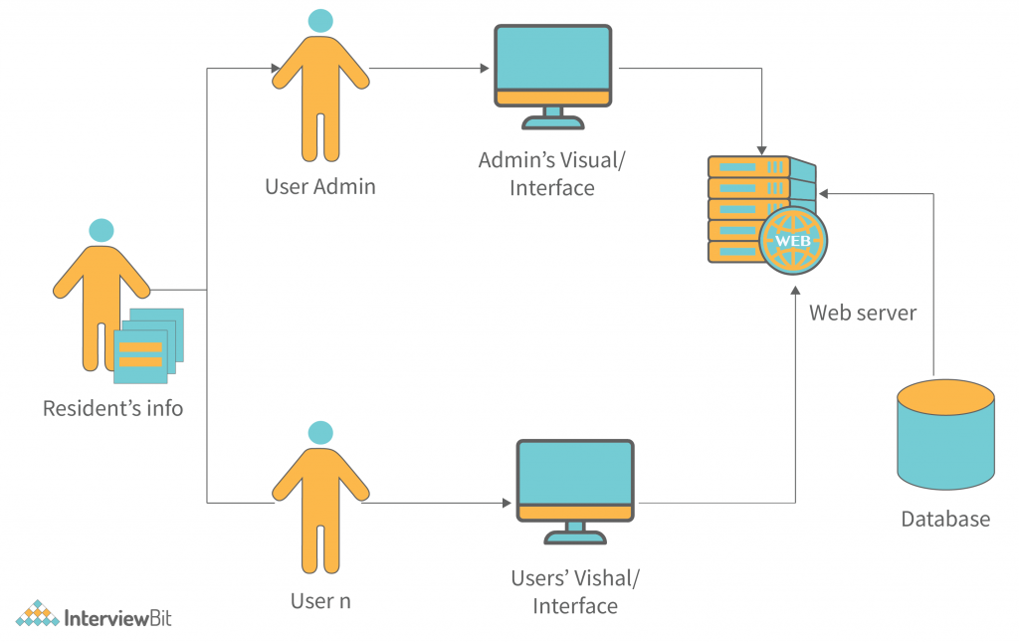
Now, development teams must be divided into different regions to ensure that all the systems are developed on the client side by one team and that the backend is developed by another team, and the database is developed by the last team.
The team will work with a common system architecture diagram, and they will be able to use it as a reference when designing their new system. A common architecture diagram for a new system provides a good starting point for the team to work from. It provides a common language for communicating system design, as well as a way to track the status of the system.

Benefits of Using System Architecture
The following are benefits associated with system architecture.
- The system architecture diagram is a visual representation of the software architecture. It depicts the system architecture, including its context, components, relationships, and dependencies. The key to a good system architecture is to clearly communicate its requirements to your stakeholders and developers and to have a well-defined system architecture from the beginning. A well-defined system architecture enables you to focus on the development of the software, and avoid long-term problems with integration and operational issues.
- Customer satisfaction provides the key to great architecture. If you do not hear the customers’ voices in your decision-making, you will not know what direction to take. It does not matter how great the architect is if the customers do not buy the product. The same applies to your software architecture. It does not matter how good the developer is if the end-user does not feel comfortable with the software. In order to know what to build and how to build it, you need to know what the customer values and how to keep them happy.
- The diagram shows the customer value that a supplier’s product or service adds to the customer’s business. It also shows the value of the supplier’s market position to potential customers. As a supplier’s value increases, so does the diagram’s importance. For a high-value supplier, the diagram is often expanded to show the customer value the supplier’s solution adds to the customer’s business.
- It is essential that you make it a point to keep your system architecture diagrams up to date. The system architecture diagram shows the current state of the system and the dependencies between the modules. Outdated or incorrect diagrams can cause a lot of trouble. The regulatory bodies need to see an up-to-date system architecture to make sure that the system complies with their standards. When the regulatory bodies’ standards become complacent, your reputation decreases in their eyes and they can fine you up to billions of dollars. When the regulatory bodies’ standards are out of date, they can negatively impact your company’s reputation.

System Architecture Diagram Examples
It is critical to become familiar with the system architecture in order to appreciate its implications. In this section, we will discuss the system architecture in more detail.

1. System Test Architecture Diagram
The software is also checked using the data provided by the operational layers, which includes information about how the software is used by users. This data is collected using metrics and measurements that are connected to the data, such as the number of failed test cases, time to fail test cases, and average time to failure. The system also tests the code against the data that is provided by the business users, including how the software is used by the business users and how the system is used by partners and customers of the business. This data is gathered using the usage data that is connected to the data, such as the number of requests for the software, the number of times the software was used, and the amount of data used for each request. The system is also connected to the data that is provided by the users, such as how the software is used by end users, what problems the users have, and what actions the users take to improve the software. Combining information about how many questions were asked, how many answers were given, and how many recommendations were given, this data can help improve the system.
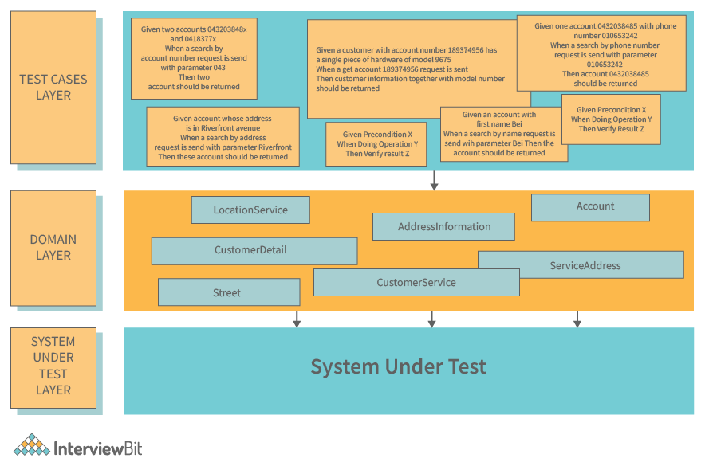

2. Content Assignment System Architecture Diagram
The database structure also includes the process of receiving assignments and assigning them to students or learners. This process may be implemented as a workflow or a set of procedures. In either case, the process of receiving an assignment and assigning it to a student or learner is known as assignment tracking. This process is implemented as a workflow and thus the architecture is referred to as a workflow-based architecture.
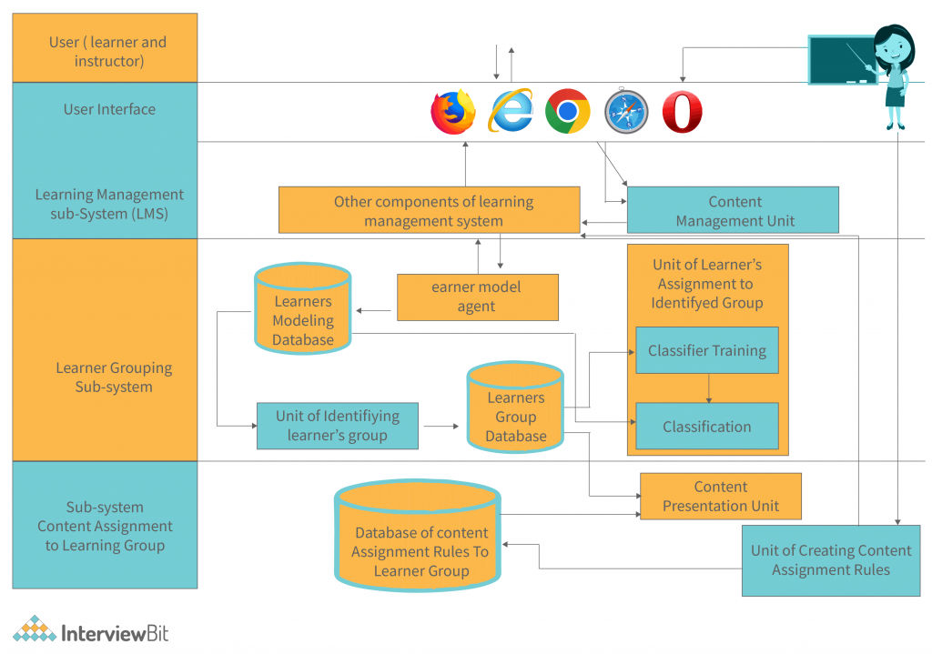

3. E-Learning System Business Architecture Diagram
The learning process then consists of the following activities: collection of data, analysis of data, presentation of learning material, evaluation of learning material, and closing of the learning process. The presented system architecture diagram is intended for the E-learning System Business Architecture. The system architecture is a representation of the business or customer requirements. The diagram illustrates all of the components that make the system function. As outlined in the overview, the architecture illustrates how the system functions in general. The system, as a hypothetical user, first registers himself via The presented system architecture diagram is intended for the E-learning System Business Architecture. The system architecture is a representation of the business or customer requirements. The diagram illustrates all of the components that make the system function. As outlined in the overview, the architecture illustrates how the system functions in general. The system, as a hypothetical user, first registers himself via the client application and this information is saved in the database. The student may now gain access to the material in the learning. The learning process then consists of the following activities: collection of data, analysis of data, presentation of learning material, evaluation of learning material, and closing of the learning process.
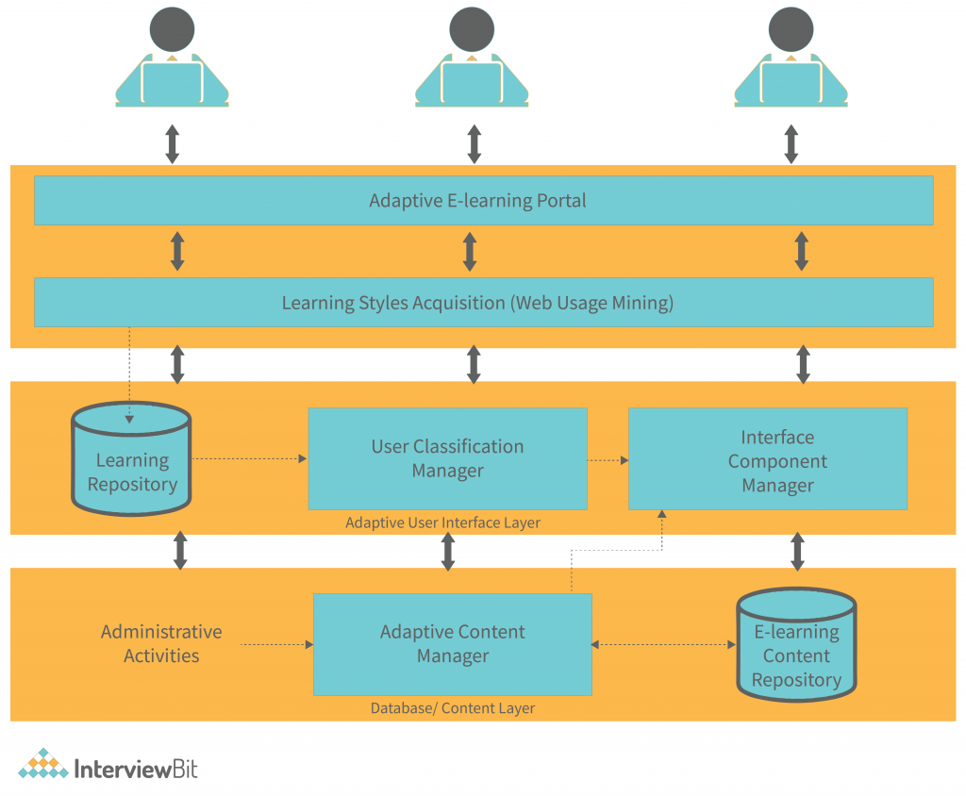

Conclusion
The design of an application involves many factors, including the software architecture. An application architecture describes the structure of the software, including its components, data models, and programming models. It also describes how the application is built and maintained, including how it is tested and maintained. The architecture of an application can be divided into three main categories: The first category is the software architecture. This describes the structure of the software, including its components, data models, and programming models. It also describes how the application is built and maintained, including how it is tested and maintained. The second category is the software development model. This describes how the application is built and maintained, including how it is tested and maintained. The third category is the maintenance model. This describes how the application is maintained, including how it is tested and maintained. The application architecture should be designed to meet the needs of both current and future users. It should be flexible enough to accommodate changes in technology and user needs while providing a solid foundation for future growth.

